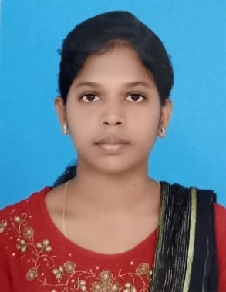

NIVE DEEPIKA

To work as a Software Engineer applying my knowledge in the ﬁeld of designing, and maintenance to cater to the speciﬁc needs of the people. I commited to continous learning,teamwork and staying abreast of emerging technologies to drive progress and exceed expectations in a dynamic and collaborative professional environment.



[**deepikanivedeepika@gmail.com**](mailto:deepikanivedeepika@gmail.com)

**7604919283**



**https://www.linkedin.com/in/nivedeepika**

**Ramanathapuram,India**

# SKILLS

* Python
* Java
* Html
* Css
* JavaScript
* MySQL

**TOOLS**

* Power BI
* Android Studio

**EDUCATION**

## BE CSE

### Easa College of Engineering and Technology

*07/2019 - 05/2022*, ***CGPA 8.41 Till 6th Sem***

## HSC

### St.Andrews Girls Higher Secodary School

*06/2019 - 04/2020,* ***Percentage-79%***

## SSLC

### DD Vinayagar Higher Secondary School

*06/2017 - 04/2018*, ***percentage-93.1%***

**COURSE CERTIFICATES**

* **Python**
* **Provider-** Edu Prep
* **Responsive Web Design**
* **Provider-**Free Code Camp
* **Android App Development**
* **Provider-**Internshala
* **Flutter Zero to Mastery**
* **Provider-**Udemy

# LANGUAGES

**Tamil**

Full Professional Proﬁciency

**English**

Working Proﬁciency

# INTERESTS

* **Web Developer**
* **Software Developer**
* **Software EngineerINTERNSHIP**
* **Computer Vision and Deep Learning Intern(20-08-2023 - 26-08-2023)**

**(Top Engineers)**

Completed a dynamic internship program specializing in computer vision technologies. Gained hands on experience in developing and implementing computer algorithms for image analysis and object detection**.**

* **Data Analysis Intern(08-2023 - 10-2023)**

**(Senchola Technology)**

Completed a comprehensive internship program focused on data analysis and data driven decision-making.Successfully conducted data collection ,cleaning and preprocessing tasks to ensure data quality and accuracy.Gained proficiency POWERBI,SQL,Python.